Creating a new style
Creating a new style involves editing/importing a border/template file, copying the XML file with options and bulkloading the new style into the catalog.

Modifying Existing SP3D Border
- Copy and paste the file Iso_Pipeline.igr file in \\[Server]\Symbols\PmfgIsoStyleData
- Rename the copy UserIso_Pipeline.sha
- Open the UserIso_Pipeline.sha file
- Save the file and exit Drawings Editor.
- Rename the copy UserIso_Pipeline.igr

Importing existing DGN border/seed file
- If you have an existing DGN or DWG file which is being used as seed/border, it can be re-used for SP3D isometrics.
- If using DGN file, first, using MicroStation tools, merge the seed and border file into a single DGN file. Note the desired size of the isometric drawing.
- Using Windows Explorer, navigate to [Workstation Install Directory]\Common2D\Shape2D\Template and locate the Normal.sha file.
- Remove the read-only flag from the file using its property page.
- Open file.
- Go to File – Sheet Setup and change the size of the file to match the desired size of the DGN file.
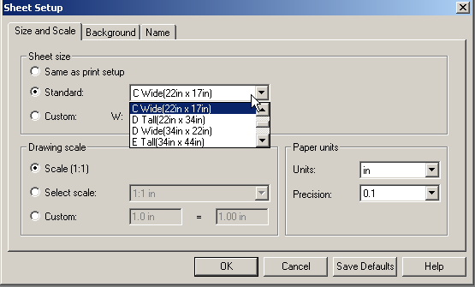
- Save the file
- Close the file
- Start Drawing Editor.
- File – Open and navigate to the DGN file.
- Change background color (if necessary) using Tools – Options and make other changes as required.
- Save the file as a UserIso_Pipeline.sha
- Rename the file as UserIso_Pipeline.igr

Bulkloading the new style
- Open the file Bulkloadisokeys.xls from [Install Directory]\CatalogData\Bulkload\DataFiles.
- Select row 6 (Iso_Pipeline) and right-mouse Copy.
- Select row 11 (End) and right-mouse Insert Copied Cells.
- Add letter A in column A of row 11
- Change Iso_Pipeline to UserIso_Pipeline in the IsoNames column
- Change OutPutIsoDrawingsLocation to IsoDrawings\UserIso_Pipeline
- Change IsoBackingSheet to PmfgIsoStyleData\UserIso_Pipeline.sha
- Change IngrOption to PmfgIsoStyleData\UserIso_Pipeline.xml
- Save the excel spreadsheet and close Excel.
- Browse to the folder PmfgIsoStyleData in the Symbols share on the server and copy the file, Iso_Pipeline.xml, rename it to be UserIso_Pipeline.xml and uncheck the read only property for the files.
- Open the UserIso_Pipeline.xml file using a text editor and use the search tool for the word Iso_Pipeline. Change all occurrences of Iso_Pipeline to UserIso_Pipeline
- Save the file.
- Start the Bulkload utility using Start → Programs → Intergraph SmartPlant 3D → Database Tools → Bulkload Reference Data
- Click the Add button and add the BulkloadIsoKeys.xls from \CatalogData\Bulkload\DataFiles
- Change the bulkload mode to Add/Modify/Delete records
- Pick the server, catalog and catalog schema name
- In the log file field, select the ellipsis (…) button and click OK.
- Click Load to load the new style into the catalog.
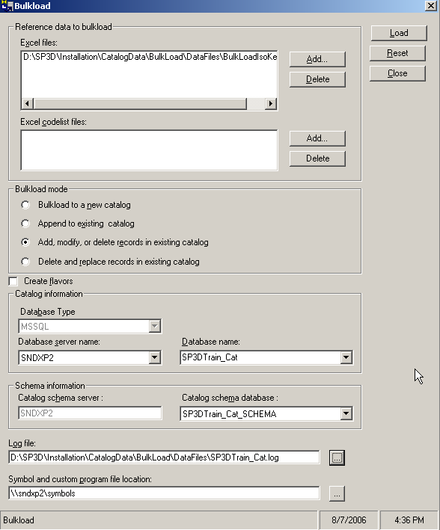
- Review the log file , it should say
Successfully created the object in row [11]
- Enter SmartPlant 3D, switch to the Drawings and Reports task. Now follow steps from earlier exercises to create a package, add a query manager etc to create isometric drawings.

